**Team - 297**

**Software Requirement Specifications**

1. **Introduction:**

**Purpose**

The main objective of the document is to illustrate software design and

**Product Scope**

In response to the exponential growth of digital content consumption and the subsequent challenge of navigating extensive movie databases, a pioneering software solution has emerged. This innovative platform is meticulously designed to elevate user experience through the integration of advanced search functionalities and enriched video playback options. Leveraging the capabilities of MongoDB Atlas Search, the software seamlessly integrates cutting-edge features such as autocomplete, fuzzy matching, and semantic search. This introduction sets the stage for a detailed exploration of how this software addresses the evolving needs of users in efficiently exploring movie databases and enjoying an immersive video playback experience.

1. **Functional Requirements:**

* **User Profile Management:**

1. **Registration and Login:**

* Users can create accounts by registering with the software, providing necessary information such as username, email and password.
* Upon registration , users can login securely using their credentials.

1. **Viewing account details:**

* The software provides users with the capability to view their account details, including profile information and preferences.
* Users can access a dashboard or profile page displaying relevant information such as username, email, and other personalised settings.

1. **Change Password:**

* Users have the option to change their profile password for enhanced security.
* This feature allows users to update their passwords as needed, ensuring account protection and privacy.

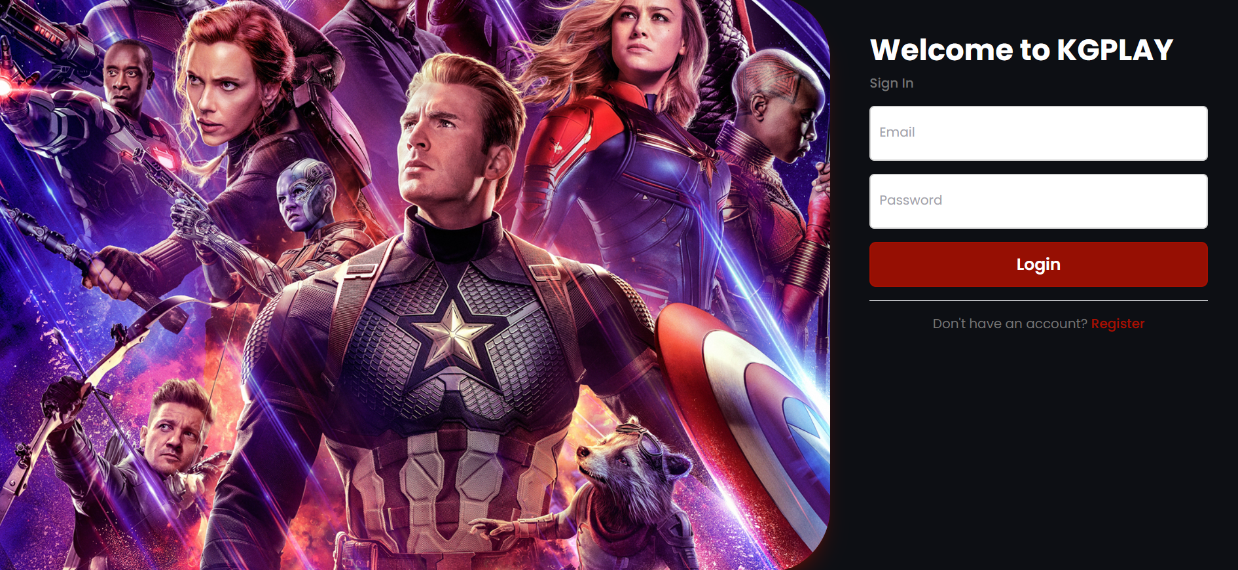

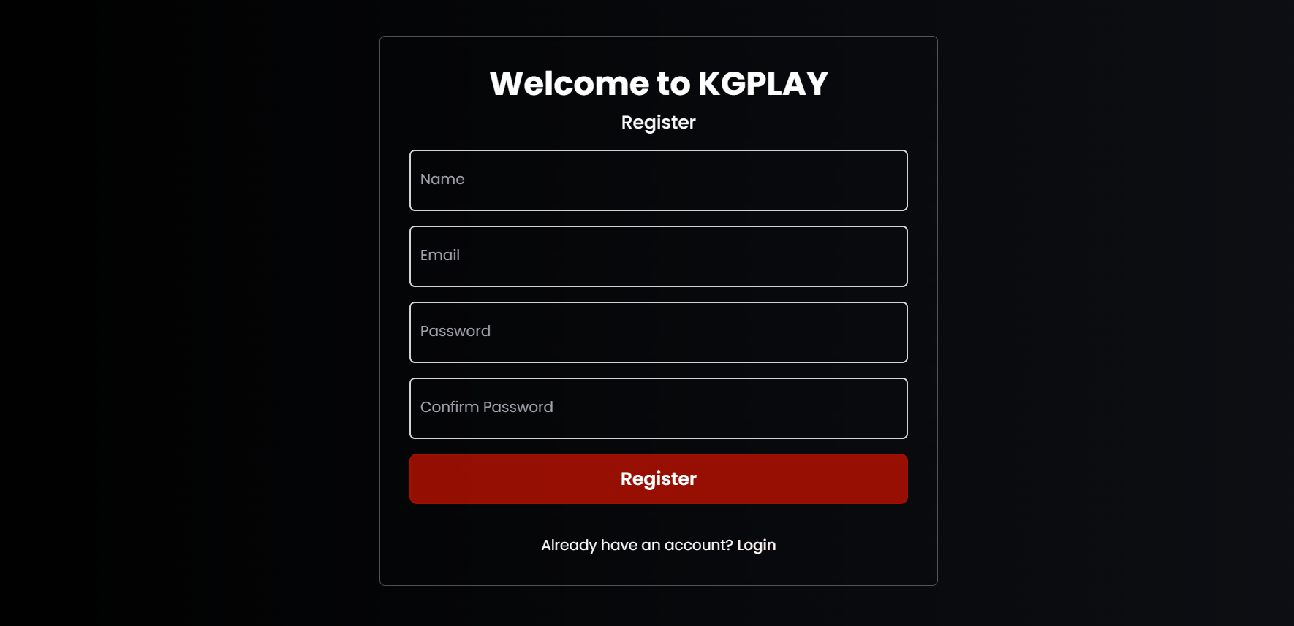

* **Different Search Functionality:**

**The software provides three different search functionalities to the users for better viewing experience.The different search functionalities are as follows:**

* **Fuzzy Search:**

Fuzzy search functionality is employed to enable users to locate movies despite slight variations or misspellings. This capability is integrated into MongoDB's search functionality. When a search query is transmitted from the frontend to MongoDB, it is translated into a Regex expression. This Regex expression efficiently identifies documents in MongoDB that correspond to the search query, allowing relevant movie cards to be returned to the frontend.

* **Autocomplete Search:**

Autocomplete search functionality offers suggestions for incomplete queries entered by users. The partial query is transmitted to the MongoDB database, where text indexes are utilized along with the $autocomplete operator to efficiently retrieve relevant suggestions based on the partial query. These suggestions are then employed to search for documents that match the suggestion and are subsequently presented to the frontend as cards.

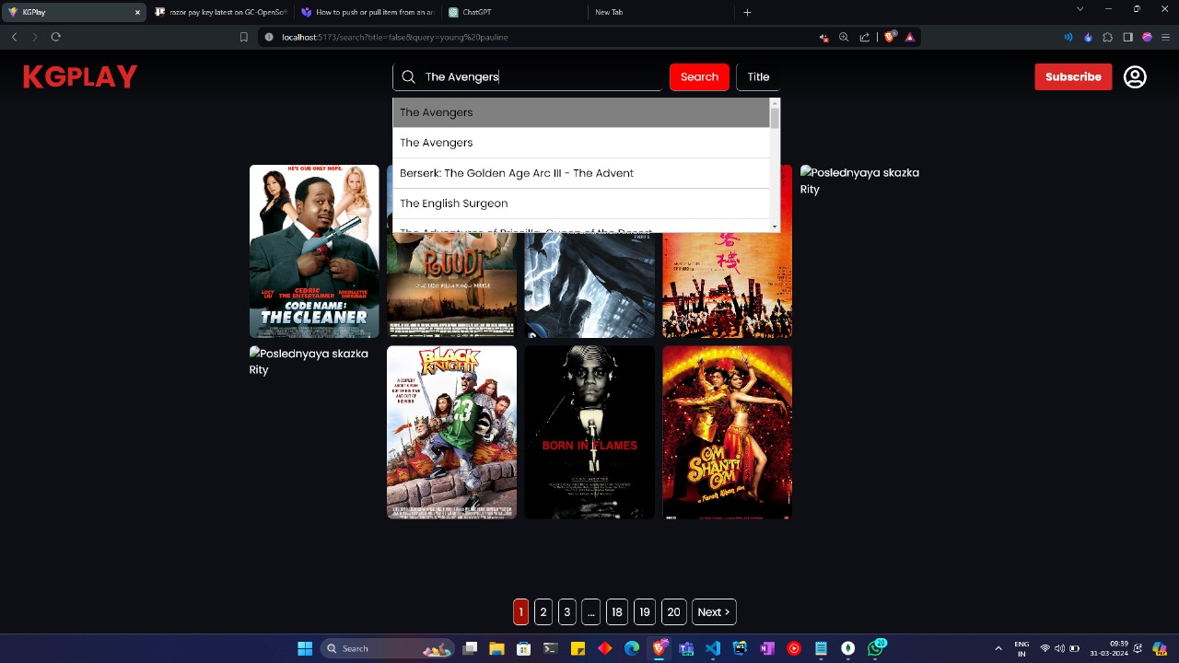

* **Semantic Search:**

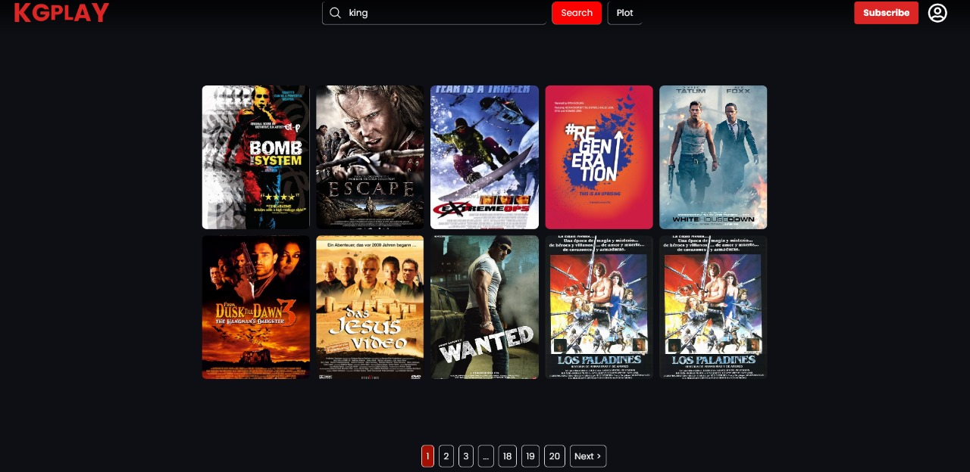Semantic search endeavours to grasp the intention and context behind a search query in order to furnish more pertinent results. When a user inputs a query pertaining to a movie's plot, this query is transformed into vector embeddings through the text-embedding Ada model developed by OpenAI. Subsequently, this embedding is forwarded to MongoDB, where it is utilized to search for documents containing plots akin to the search query using the k-nearest neighbours (KNN) model. The retrieved movie cards are then relayed to the frontend for presentation.

* **Subscription Model Integration:**

The website offers three subscription tiers, each granting users access to additional features upon purchase. Users can opt for different tiers of subscription, paying a recurring fee. To facilitate seamless payment processing, the website is integrated with the Razorpay payment gateway. Upon successful payment, the selected tier becomes active, and users gain access to the corresponding additional features.

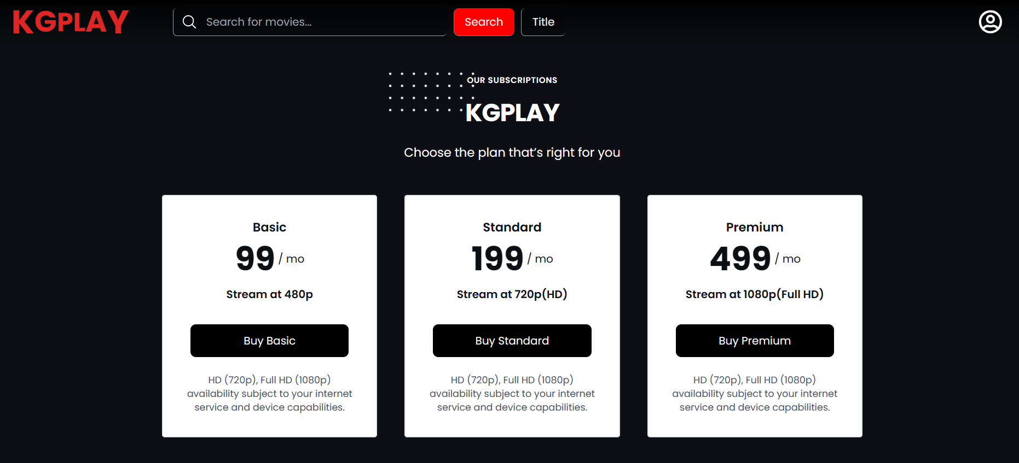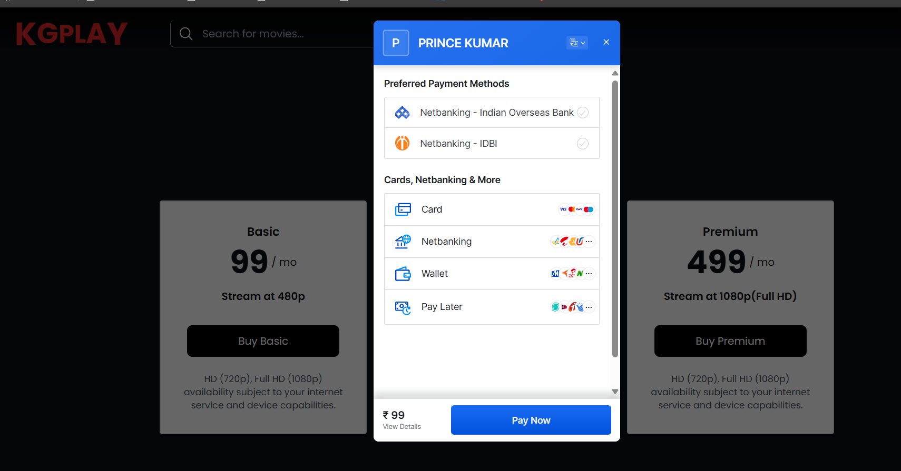

* **Advanced Video Playback:**

The website offers users the ability to stream high-quality videos with advanced features including video resolution control, playback speed adjustment, and picture-in-picture functionality. Additionally, it dynamically adjusts the stream quality based on network conditions using the auto option. Overall, the platform is designed to deliver a seamless video streaming experience.



**3. Interface Requirements:**

* **User Interface:**

1. **Navbar:**

The website's navigation bar includes the site's logo, a search bar for multiple search functions, an account icon positioned on the right, and a subscription button. Clicking the subscription button opens the subscription page, while clicking the account icon reveals a dropdown menu with options to visit the profile page and the change password page. Additionally, there is an option to logout.



1. **Landing Page:**

The landing page showcases the selection of movies available on the platform, featuring top-rated films as well as movies sorted by various genres. The hero section highlights popular movies, providing users with easy access to compelling content. Clicking on any movie card directs users to the respective movie page for further exploration.



1. **Movie Page:**

The movie page provides a synopsis of the plot, along with the movie's rating. A prominent play button allows users to initiate playback of the film. Additionally, a carousel showcases similar movies related to the selected one, offering users suggestions for further viewing.



* **Software Interface Requirements:**
* **Frontend:**

1. React
2. Flowbite

* **Backend:**

1. Express
2. NodeJs
3. Mongoose

**4. Security Requirements**

* **JWT Authorization**

The software provides a secure login mechanism, ensuring that users can authenticate themselves reliably. Upon successful authentication, the system generates JWT (JSON Web Token) tokens, which play a crucial role in enforcing security measures throughout the application. These tokens are meticulously designed to contain encoded information about the user's identity and any pertinent authorization data.

By leveraging JWT tokens, the system establishes a robust framework for authentication and authorization. Each token is cryptographically signed, ensuring its integrity and authenticity. Furthermore, JWT tokens have a built-in expiration mechanism, enhancing security by limiting their lifespan.

Throughout the user's session, these tokens are utilised to grant access to authorised resources and functionalities within the system. They serve as portable credentials, eliminating the need for the user to repeatedly provide their username and password for every request.

Overall, the integration of JWT tokens enhances the system's security posture, enabling seamless and efficient authentication and authorization processes for users while safeguarding sensitive information and resources.

**HIGH LEVEL DESIGN**

* **CONTROL FLOW DIAGRAM:**

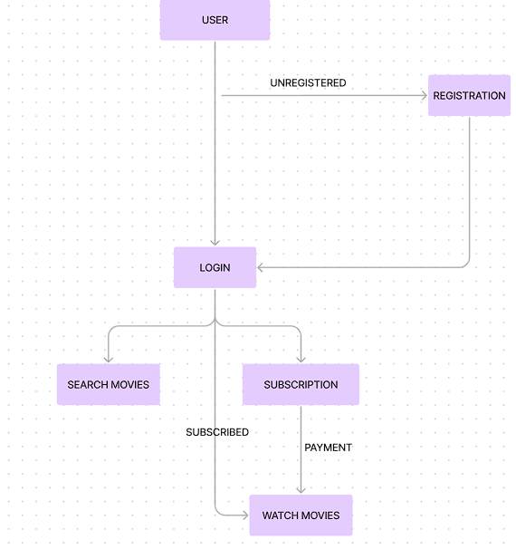

* **DATA FLOW DIAGRAM:**

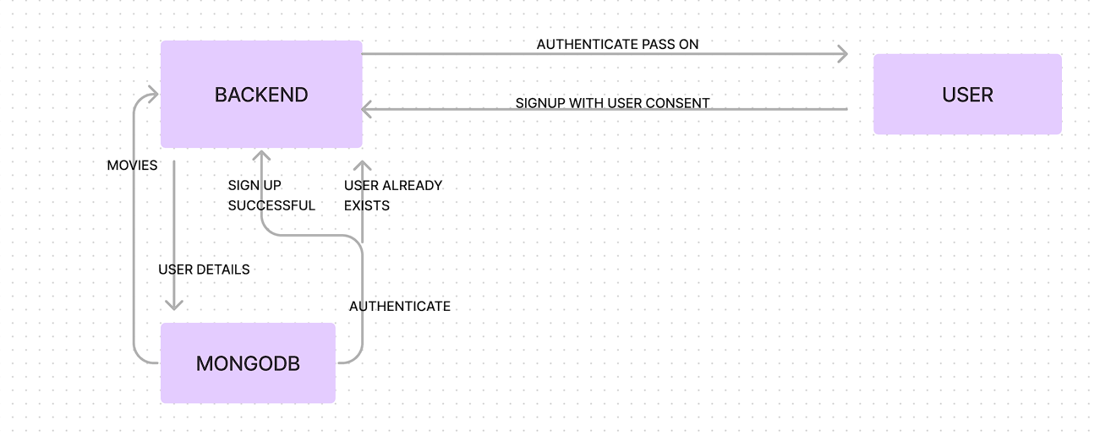

* **CLASS DIAGRAM:**

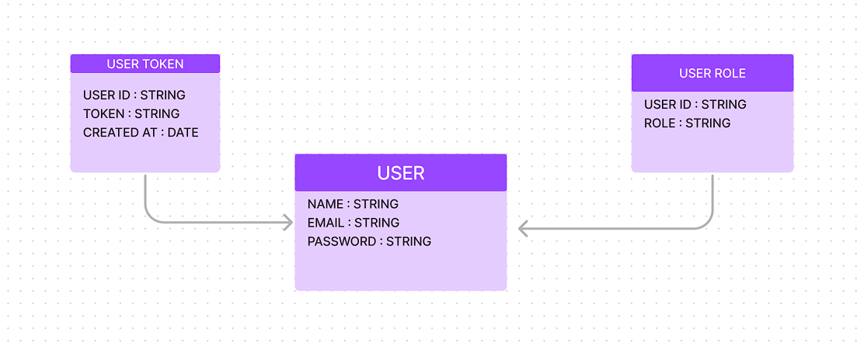

* User
  + **Login** : The endpoint receives a request containing the user's email and password, and subsequently verifies the validity of the provided credentials. Following this authentication process, the endpoint returns a JSON response with the message: "User logged in successfully". Additionally, the response includes a boolean indicator of success denoted by "success: true", the user's assigned role(s) retrieved from the giuserRole.Role, an access token (accessToken), and a refresh token (refreshToken).
  + **Register** : The endpoint receives input parameters which include the user's name, email, and password. If a user with the provided email does not exist, the endpoint proceeds to create a new user. Subsequently, a JSON response is generated with the message: "User created successfully", accompanied by indicators of success denoted by "success: true", the user's assigned role(s) retrieved from userRole.Role, an access token (accessToken), and a refresh token (refreshToken).
  + **Patch** : This endpoint is designed to accept both the current password and the new password as part of the request. Upon receiving the request, the endpoint first validates the existence of the user. Subsequently, it verifies the correctness of the provided current password, enabling the update of the user's password with the new one. Following this operation, the endpoint generates a JSON response message confirming the successful update of the password, accompanied by an indicator denoting success: "Password updated", success: true. It is secured using the verification of an access token, ensuring that only authenticated users are granted access to their profile
  + **Delete** : This endpoint is designed to accept password as part of the request. Upon receipt of the request, the endpoint proceeds to locate the corresponding user and subsequently initiates the deletion process for the identified user account. Upon successful deletion, the endpoint generates a response message confirming the action with "User deleted", alongside an indication of success denoted by "success: true". Additionally, the endpoint ensures the removal of all associated cookies for comprehensive user data clearance. It is secured using the verification of an access token, ensuring that only authenticated users are granted access to their profile.
  + **Get** : This endpoint is responsible for retrieving the user profile information. It is secured using the verification of an access token, ensuring that only authenticated users are granted access to their profile data.
* Admin
  + **Get users** : In the event that an administrator initiates a GET request to this particular endpoint, the resulting response comprises a JSON structure encompassing the user's ID, name, and email information.
* Refresh Token
* **Get** : When a GET request is made to the specified endpoint, it invokes the `getNewRefreshToken` handler, which is responsible for obtaining a new refresh token, generating new access and refresh tokens, and returning them in the response. This endpoint is typically used when a user needs to refresh their authentication tokens.
* **Delete** : When a DELETE request is made to the same URL, it invokes the `deleteRefreshToken` handler, which is responsible for deleting the refresh token associated with the user's session. This effectively logs the user out by removing their authentication tokens.
* Subscription
  + **Update role** : This endpoint accepts a user role as part of the request and facilitates the modification of the user's assigned role. Upon successful execution, the endpoint generates and sends a response message indicating the completion of the role change operation.
* Payment
  + **getKey** : The GET request at the "/getkey" endpoint upon receiving a request, the handler logs a message indicating that the endpoint has been accessed. Finally, it sends a JSON response with a status code of 200, containing the Razorpay key ID retrieved from the environment variables.
  + **create/order-id** : The endpoint is a POST request to create an order ID. Upon receipt, it logs request details and constructs order parameters. After creating the order, it responds with the generated order ID. Error handling is implemented to address potential validation errors, with specific handling for Joi validation issues.
  + **Verify** : This endpoint is designed to handle POST requests for verifying payment transactions via Razorpay. It concatenates the order ID and payment ID from the request body, generates an HMAC-SHA256 signature using the provided secret key, compares it with the received signature, and responds by affirming the validity of the payment transaction signature.
* MovieSearch
  + **Plot** : The endpoint accepts the plot of the movie as a request and utilises the OpenAI API to generate vector embeddings. Subsequently, it conducts a vector search within the MongoDB database, retrieving movie titles and corresponding plots based on similarity measures. Finally, the endpoint returns the response containing the identified movie titles and associated plots.
  + **Title** : This endpoint functions by receiving a title as input and employs fuzzy and autocomplete indexes within the MongoDB database to conduct a search for the corresponding plot. Subsequently, it executes sorting operations based on various criteria such as exact match, first word match, and other scoring metrics to refine and prioritise the search results.

**ANNEXURE**

**FRONTEND**

**Dependencies Used**

* **Hookform/resolvers** : ^3.3.4
  + The `@hookform/resolvers` library provides resolver functions for form validation with React Hook Form.
* **Axios** : ^1.6.8
  + Axios is a popular HTTP client library for making asynchronous requests in JavaScript.
* **Flowbite-react** : ^0.7.3
  + Flowbite-react is a UI component library for React applications, offering a collection of ready-to-use components for building modern user interfaces.
* **Framer-motion** : ^11.0.14
  + Framer Motion is a React library for creating fluid and expressive animations in web applications, providing a rich set of features for building interactive user interfaces.
* **Js-cookie** : ^3.0.5
  + Js-cookie is a lightweight JavaScript library for handling browser cookies, simplifying the process of setting, getting, and deleting cookies in web applications.
* **react** : ^18.2.0
  + React is a JavaScript library for building user interfaces, offering a powerful and efficient way to create interactive and dynamic web applications.
* **React-dom** : ^18.2.0
  + React-DOM is a package that serves as the entry point for working with the DOM (Document Object Model) in React applications, facilitating the rendering of React components into the browser.
* **React-hook-form** : ^7.51.0
  + React Hook Form is a library for managing form state and validation in React applications using hooks, providing a simple and efficient way to handle form inputs with minimal boilerplate code.
* **React-icons** : ^5.0.1
  + React Icons is a library that provides a collection of popular icon sets as React components, allowing developers to easily incorporate icons into their React applications without relying on external image files or fonts.
* **React-paginate** : ^8.2.0
  + React-paginate is a React component library for creating paginated navigation interfaces in web applications, offering features such as customizable pagination controls and event handling.
* **React-router-dom** : ^6.22.3
  + React-router-dom is a package that provides routing capabilities for React applications, enabling developers to implement client-side routing and navigate between different views or pages in a single-page application (SPA) using declarative components.
* **Zod** : ^3.22.4
  + Zod is a TypeScript-first schema validation library for JavaScript and TypeScript projects, offering a simple and intuitive API for defining and validating data schemas with runtime type checking capabilities.

**BACKEND**

**Dependencies Used**

* **Bcrypt** : ^5.1.1
  + Bcrypt is a widely-used cryptographic library for Node.js, primarily employed for hashing passwords and providing secure password storage mechanisms in web applications.
* **Cookie-parser** : ^1.4.6
  + Cookie-parser is a middleware for Express.js applications that parses HTTP request cookies, making it easier to handle and manipulate cookie data within the server-side code.
* **Cors** : ^2.8.5
  + Cors is a middleware for Express.js that enables Cross-Origin Resource Sharing (CORS) in web applications, facilitating communication between different domains.
* **Dotenv** : ^16.4.5
  + Dotenv is a zero-dependency module that loads environment variables from a .env file into process.env, simplifying configuration management in Node.js applications.
* **Express** : ^4.18.3
  + Express is a fast and minimalist web framework for Node.js, providing a robust set of features for building web servers and APIs.
* **Express-async-handler** : ^1.2.0
  + Express-async-handler is a utility middleware for Express.js that simplifies error handling for asynchronous request handlers, allowing developers to use async/await syntax without worrying about try/catch blocks.
* **Express-validator** : ^7.0.1
  + Express-validator is a middleware for Express.js that provides flexible and powerful validation functionalities for incoming request data, helping to ensure data integrity and security in web applications.
* **Http-errors** : ^2.0.0
  + Http-errors is a utility for creating HTTP error objects with meaningful status codes and error messages in Express.js applications, facilitating error handling and response management.
* **Joi** : ^17.12.2
  + Joi is a schema validation library for JavaScript and Node.js, offering a declarative API for defining and validating data schemas with support for complex validation rules and error messages.
* **Jsonwebtoken** : ^9.0.2
  + Jsonwebtoken is a library for generating and verifying JSON Web Tokens (JWT) in Node.js applications, enabling secure authentication and authorization mechanisms.
* **Mongoose** : ^8.2.2
  + Mongoose is an Object Data Modeling (ODM) library for MongoDB and Node.js, providing a straightforward schema-based solution for modelling application data and interacting with MongoDB databases.
* **Morgan** : ^1.10.0
  + Morgan is a middleware for Express.js that logs HTTP request details, including request method, URL, status code, response time, and more, facilitating server-side logging and debugging in web applications.
* **Razorpay** : ^2.9.2
  + Razorpay is a payment gateway solution for Indian businesses, offering a platform for processing online payments securely and efficiently, with support for various payment methods and integrations.